LAB EXPERIMENT RECORD
Set 16: Customer Demographics Analysis
Department | AIML
Course Code / Course Name | DSA0601 / Data Handling and Visualization
Experiment | Data Visualization using R and Tableau
Name | G. GANGA CHANDRIKA
Register Number | 1925260144
Date | 19 October 2026
Day | Monday
Aim
To visualize customer demographic data using a bar chart, a pie chart and a labelled table in R, and to combine them into a single interactive dashboard.
Dataset: Customer Demographics
Customer ID | Age | Gender | Income ($)
1 | 28 | Female | 50000
2 | 35 | Male | 60000
3 | 42 | Female | 75000

PROGRAM 1: Bar Chart of Customer Ages
Create a bar chart to visualize the distribution of customer ages. Label the axes and title the chart.
# Create the dataset
customers <- data.frame(
Customer_ID = c(1, 2, 3),
Age = c(28, 35, 42),
Gender = c("Female", "Male", "Female"),
Income = c(50000, 60000, 75000)
)

# Create the bar chart
barplot(
table(customers$Age),
main = "Distribution of Customer Ages",
xlab = "Customer Age (Years)",
ylab = "Number of Customers",
col = "skyblue"
)
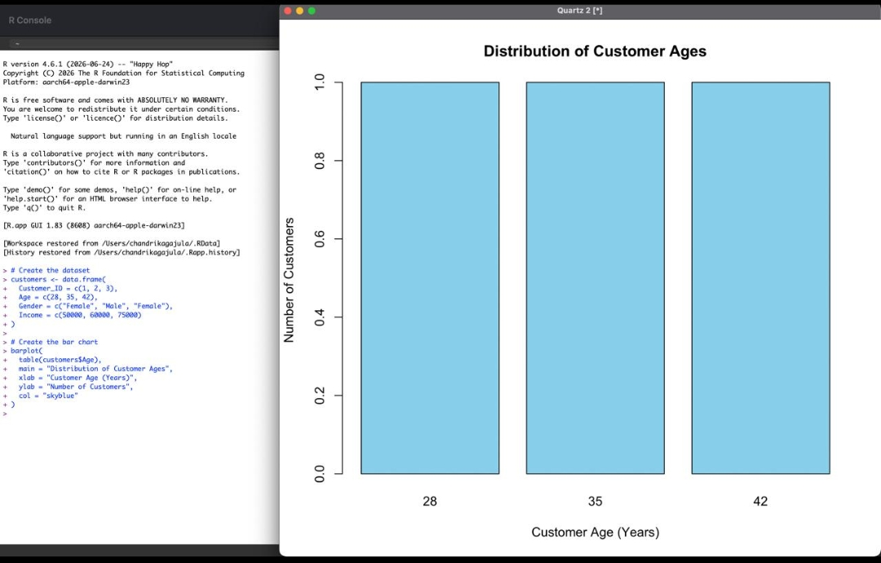
Output 1: Distribution of Customer Ages (Bar Chart)
Observation: Each age group (28, 35 and 42) has exactly one customer, so all three bars have equal height.
PROGRAM 2: Pie Chart of Customers by Gender
Generate a pie chart to represent the distribution of customers by gender.
# Count customers by gender
gender_count <- table(customers$Gender)

# Create the pie chart
pie(
gender_count,
main = "Distribution of Customers by Gender",
col = c("pink", "lightblue"),
labels = paste(
names(gender_count),
round(100 * gender_count / sum(gender_count), 1),
"%"
)
)
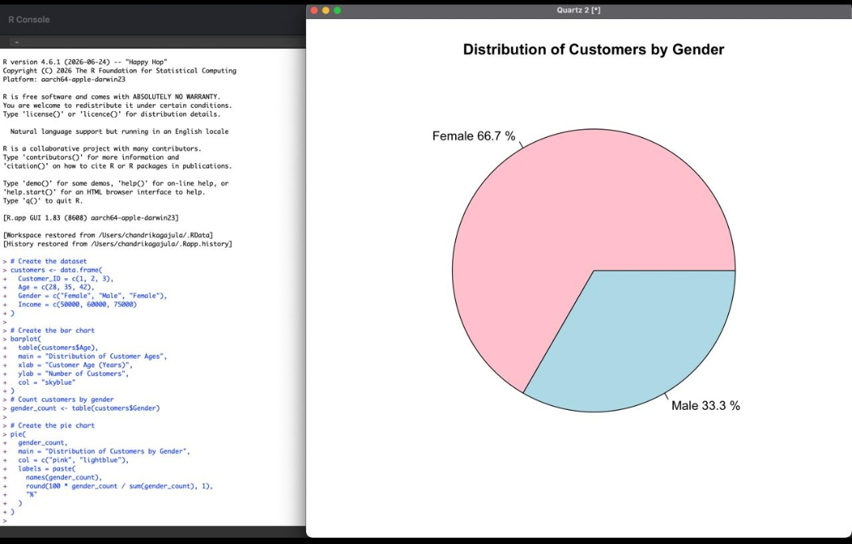
Output 2: Distribution of Customers by Gender (Pie Chart)
Observation: Female customers make up 66.7% (2 of 3) and male customers make up 33.3% (1 of 3).
PROGRAM 3: Customer Demographic Table
Build a table to show the demographic information for each customer. Label the table elements.
# Create the demographic table
demographic_table <- data.frame(
Customer_ID = customers$Customer_ID,
Age = customers$Age,
Gender = customers$Gender,
Income = customers$Income
)

# Display the table
print(demographic_table)

# Add labels
cat("Table: Customer Demographic Information\n")
cat("Columns: Customer ID, Age, Gender, Income ($)\n")
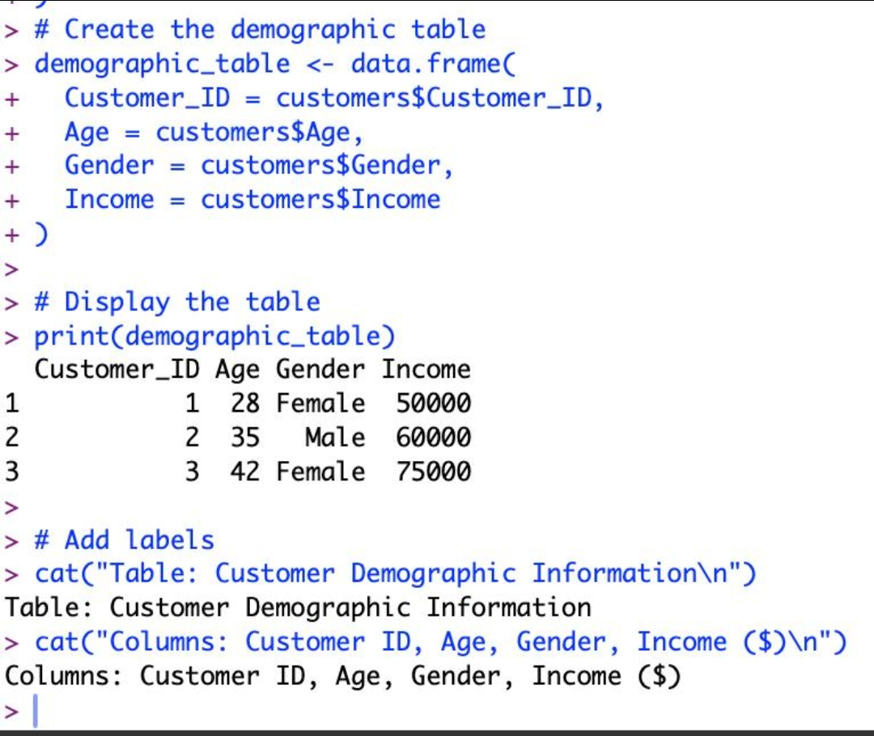
Output 3: Customer Demographic Information Table
Observation: The table lists the Customer ID, Age, Gender and Income of all three customers, with labelled columns.
PROGRAM 4: Dashboard Combining Bar Chart, Pie Chart and Table
Develop a dashboard combining the bar chart, pie chart and table.
# Dashboard layout (2 x 2 grid)
layout(matrix(c(1, 2, 3, 3), nrow = 2, byrow = TRUE))

# Bar chart
barplot(table(customers$Age),
main = "Distribution of Customer Ages",
xlab = "Age (Years)", ylab = "Number of Customers",
col = "skyblue")

# Pie chart
gender_count <- table(customers$Gender)
pie(gender_count, main = "Customers by Gender",
col = c("pink", "lightblue"),
labels = paste0(names(gender_count), " ",
round(100 * gender_count / sum(gender_count), 1), "%"))

# Table display
plot.new()
title("Customer Demographic Information")
text(x = 0.5, y = 0.85, labels = "ID Age Gender Income ($)", font = 2)
text(x = 0.5, y = 0.65, labels = "1 28 Female 50000")
text(x = 0.5, y = 0.48, labels = "2 35 Male 60000")
text(x = 0.5, y = 0.31, labels = "3 42 Female 75000")
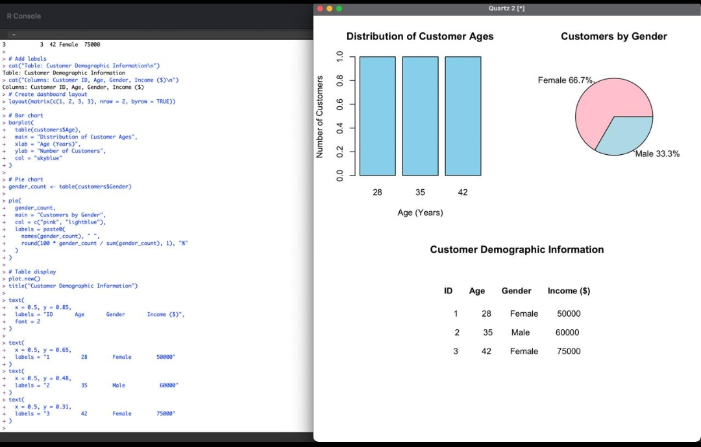
Output 4: Customer Demographics Dashboard
Observation: The dashboard shows the age bar chart, the gender pie chart and the demographic table together on one screen.
Tableau Dashboard Steps (Interactive)
1. Open Tableau and connect to the dataset (Excel/CSV with Customer ID, Age, Gender, Income).
2. Bar chart sheet: drag Age to Columns and Count of Customer ID to Rows. Edit the axis titles and set the sheet title to "Distribution of Customer Ages".
3. Pie chart sheet: choose Pie in the Marks card, drag Gender to Color and Count of Customer ID to Angle, then show the percentage labels. Title it "Customers by Gender".
4. Table sheet: drag Customer ID, Age, Gender and Income to Rows (or Text) to build the labelled demographic table.
5. Create a new Dashboard and drag the three sheets onto it.
6. Select the pie chart or bar chart sheet and enable "Use as Filter" so that clicking a gender or age updates the other charts and the table.
7. Add a title with the student name and register number, then save the workbook.
Procedure
1. Create the customers data frame with Customer_ID, Age, Gender and Income.
2. Use barplot() with table(customers$Age) to draw the age distribution, adding the title and axis labels.
3. Use table() to count customers by gender and pie() to draw the pie chart with percentage labels.
4. Create demographic_table using data.frame() and display it with print() and cat() labels.
5. Use layout() to arrange the bar chart, pie chart and table into one dashboard.
Result
The customer demographic data was successfully visualized using a bar chart, a pie chart and a labelled table, and combined into a single dashboard.
Key R Functions Used
Function | Purpose
data.frame() | Creates the customer dataset and demographic table.
table() | Counts customers by age and by gender.
barplot() | Creates the bar chart of customer ages.
pie() | Creates the pie chart of gender distribution.
layout() | Arranges multiple plots on one screen (dashboard).
print() / cat() | Displays the table and its labels in the console.
text() / title() | Draws the table and its heading inside the dashboard.

